Tri-Prong Reactive Shield Wave Spine
White Paper Proof of Concept for Three Rotating PTECs Generating Alternating Reactive Shield Corridors
Document Type | High-level shielding proof-of-concept white paper
Concept Thesis | Use three rotating Prismatic Tesseract Energy Cores (PTECs) to generate alternating overlapping EM corridors around a ship, creating reactive shielding waves that feed and strengthen a larger defensive spine or shield lattice.
Primary Use | Shield-wave generation, lattice reinforcement, stress redistribution, and moving field hardening around a protected spacecraft volume
Status | Concept architecture draft
Abstract
Tri-Prong Reactive Shield Wave Spine is a ship-scale defensive-field concept that extends earlier dual-channel and prismatic relay architectures into a three-node rotating arrangement. In this design, three PTECs are positioned on a ring, frame, or orbital track around the hull and operated as synchronized oscillation sources rather than isolated emitters. As the nodes rotate, their projected electromagnetic corridors alternately overlap, creating moving reinforcement bands or 'shield waves' around the ship. The purpose of these waves is not to replace passive armor or the full defensive lattice, but to redistribute stress, support field shaping, and feed a broader shield envelope with dynamic hardening where it is needed most.
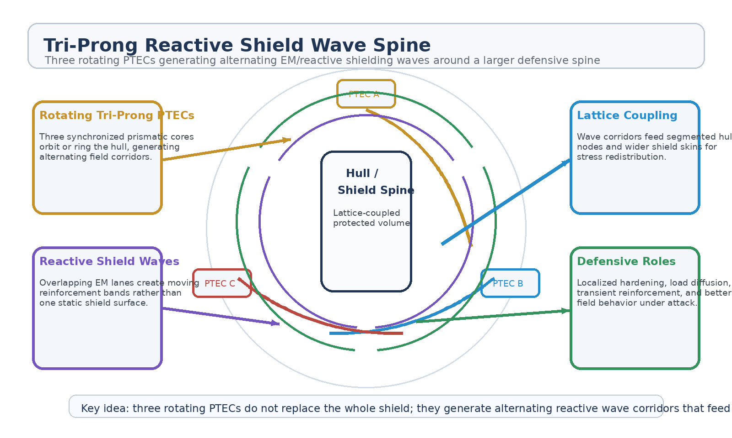
Figure 1. Tri-Prong Reactive Shield Wave Spine with three rotating PTECs, alternating wave corridors, hull-lattice coupling, and protected volume.
1. Concept Thesis
The central idea is that a shield becomes more adaptive when field strength moves. A single emitter produces a fixed dependency. A dual corridor creates balancing. A tri-prong rotating system adds the ability to sweep reinforcement around the hull in alternating bands, allowing the ship to create reactive shielding waves instead of relying on one rigid static envelope.
This reframes shielding as a managed moving-corridor problem: three PTECs create the wave lanes, and the larger hull lattice receives the benefit.
2. Why the Tri-Prong Layout Matters
• Adds a third oscillation source so the defensive field can rotate through multiple overlap states.
• Creates moving reinforcement zones rather than one fixed high-density lane.
• Improves load sharing and stress diffusion compared with a single-point shield source.
• Allows alternating field behavior that can be directed around threatened hull sectors.
• Supports stronger coupling into a wider shield lattice, segmented hull skin, or relay shell.
3. Relationship to Earlier Concepts
The earlier Dual Prismatic Shield Channel established the idea that shield strength improves when the field is treated as a corridor rather than a single isolated emitter path. The prismatic relay-network concepts extended that logic into a ship-scale lattice, where prism nodes can redirect and redistribute energy across the hull. The PTEC doctrine contributes the rotating polyhedral core logic: PTECs are not only field sources, but phase-shaped geometric engines capable of directional energy output and synchronized routing behavior.
Tri-Prong Reactive Shield Wave Spine combines those ideas. It uses three PTECs as rotating relay nodes, turns their overlapping corridors into moving reactive waves, and couples those waves into a larger defensive skin.
4. System Architecture
Layer | Subsystem | Primary Function | Role
L1 | PTEC A / B / C | Serve as three synchronized rotating oscillation sources around the hull. | Tri-prong source ring
L2 | Alternating EM Corridors | Form overlapping electromagnetic lanes as the PTECs rotate. | Wave-generation lanes
L3 | Reactive Shield Waves | Create moving reinforcement bands and transient hardening zones. | Dynamic field behavior
L4 | Shield-Lattice Coupling | Feed hull nodes, segmented defensive skin, or prism arrays. | Distributed support layer
L5 | Protected Volume | Receive the resulting stabilized and reactively reinforced envelope. | Defensive outcome

4.1 Three Rotating PTECs
Each PTEC should be treated as one member of a synchronized triad rather than as an independent emitter. Their strength lies in coordinated timing, rotational offset, and managed phase relationships. Because PTECs already carry the logic of rotational induction, geometric resonance, and directional field shaping, they fit naturally into a ship-scale rotating relay configuration.
4.2 Alternating Corridor Formation
As the three nodes rotate, the lanes between them do not remain identical. Their overlap shifts around the hull, creating alternating density states. This is the architectural basis for the shield-wave idea: not random effects, but moving bands of reinforced field behavior generated by repeated overlap and phase cycling.
4.3 Reactive Lattice Coupling
The waves matter most when they feed something larger than themselves. A shield wave by itself is only a field event. Coupled into segmented hull nodes, relay shells, or a wider prism lattice, it becomes a managed reinforcement system capable of routing defensive emphasis toward stressed sectors.
5. Defensive Roles
• Moving reinforcement against charged-particle or electromagnetic attack vectors.
• Localized hardening of hull sectors under transient stress.
• Load redistribution across shield lattices during asymmetric impact or surge conditions.
• Wave-driven support for broader segmented defensive skins.
• Improved survivability through rotating field density rather than one static shield lane.
6. Why This Is Stronger Than a Single Static Shield Source
• The field can move, overlap, and reinforce rather than remaining locked in one distribution.
• Three sources reduce dependency on one emitter or one corridor state.
• The geometry allows repeated cycling of stress across multiple hull sectors.
• The system can behave as a managed support architecture instead of a single magic shield bubble.
• It pairs more naturally with larger relay-lattice or hull-node systems already present in the ship.
7. Boundaries and Realism
Tri-Prong Reactive Shield Wave Spine is strongest as a field-management and shield-support architecture. It should not be oversold as universal protection against every damage class. Its value lies in the creation of moving reinforcement bands and improved field behavior around a protected spacecraft volume. Passive shielding, structural segmentation, and true pressure-hull resilience still matter.
• Best framed for EM, charged-particle, and field-shaped defensive roles.
• Less credible as a sole answer to every kinetic or radiation threat class.
• Most coherent when tied into a larger defensive lattice and real hull structure.
• Should be described as a wave-generating support spine, not an all-protecting bubble.
8. Proof-of-Concept Build Path
Phase | Goal | Bench / Program Activity | Success Signal
P1 | Triad source demo | Drive three synchronized PTEC-like oscillation sources in a ring configuration. | Stable tri-prong phase relationship
P2 | Corridor cycling | Demonstrate repeated alternating overlap states between the three sources. | Repeatable wave corridor behavior
P3 | Reactive wave mapping | Measure moving reinforcement bands around a protected test volume. | Trackable shield-wave pattern
P4 | Lattice coupling | Feed the rotating wave state into a segmented hull-node or shield-skin model. | Improved distributed support
P5 | Stress evaluation | Apply asymmetric field load and compare behavior against static or dual-source baselines. | More adaptive shield response

9. Conclusion
Tri-Prong Reactive Shield Wave Spine extends the earlier dual-channel idea into a more dynamic rotating architecture. Three PTECs generate alternating electromagnetic corridors, those corridors become moving reactive shield waves, and those waves strengthen a larger defensive lattice around the hull. The result is not one static bubble, but a more adaptive envelope that can move its emphasis where stress is rising.
As a white paper PoC, the concept is strongest as a support spine for ship-scale shielding: rotating PTEC triads, moving reinforcement bands, lattice-fed defense, and better field management across a protected volume.
Working one-line doctrine: Use three rotating PTECs to generate alternating overlapping EM corridors around the hull, creating reactive shield waves that feed and strengthen a larger defensive lattice.

